Calvary Chapel of El Paso Morning Ladies’ Bible Study – The Book of Hebrews
November 17, 2020 – Lesson 7 – Priest and King

Now of the things which we have spoken this is the sum: We have such an high priest,
who is set on the right hand of the throne of the Majesty in the heavens. – Hebrews 8:1

Part 1: Jesus Christ is Greater than Aaron

The Book of Hebrews was written to Christians with Jewish background. Many thousands of Jews had become Christians. Yet near the end of Paul’s life, there were many Jewish Christians who were slipping back into Old Testament ways. Hence Paul’s Book of Hebrews to them. His unequalled Jewish legal mind, scholarship, and sound doctrine in Christ made him the perfect one to speak to them. Then and now.
We have already seen in this book that Jesus Christ is superior to the angels and to Moses. And last week Shirley gave a beautiful detailed study on our Compassionate Great High Priest, comparing Him to the High Priest Aaron. We will go into more detail today and in future chapters that we will study after the first of the year.

The Hebrew mindset
Moses was the pinnacle of their faith. So the angels who were involved in all that God did with and through Moses were also highly esteemed, as well as the priesthood of Aaron that was established at that time. In their minds, they would always go back to Moses, the angels, the priesthood of Aaron, and the Law laid out through Moses. (We will get to the Law [covenant] next year. ).
Paul tread carefully here, never demeaning the angels, Moses, the priesthood – BUT he said they were great, but Christ is greater! And he made a sound legal case, which would satisfy the Hebrew mind.
(Is it possible that during the Great Tribulation Jews will pick up a Bible and look first at “Hebrews,” reading that book and what follows to the end of the Bible? Before reading elsewhere? It would certainly bring many to salvation, comfort and understanding. )
The history of Israel really began with Abraham, not Moses. (details in future chapters)
The everlasting covenant
The Angel who spoke to Abraham on more than one occasion was Christ Himself (a theophany). Christ also appeared to Abraham as Melchizedek.
The everlasting priesthood – in Melchizedek.

In the Old Testament many things are only partially revealed.
Even now we do not completely understand many things, but much more so than those of the Old Testament times.
1 Peter 1:10 Of which salvation the prophets have enquired and searched diligently, who prophesied of the grace that should come unto you: 11 Searching what, or what manner of time the Spirit of Christ which was in them did signify, when it testified beforehand the sufferings of Christ, and the glory that should follow. 12 Unto whom it was revealed, that not unto themselves, but unto us they did minister the things, which are now reported unto you by them that have preached the gospel unto you with the Holy Ghost sent down from heaven; which things the angels desire to look into.
The prophets wrote about but did not understand the salvation through Messiah/Christ. The Holy Spirit revealed to them what to write; yet it was not for them but for us in this time.
And the angels did not and do not understand; they just watch it unfold. (Satan, too)

One mystery in the Old Testament is Melchizedek. (Remember that in the Bible, a mystery is something that God had hidden from the world but reveals to His children. Mark 4:11; Romans 16:25-26; and others.) Melchizedek just appeared on the scene after Abraham had rescued his nephew Lot and those with him from the heathen kings who had captured them. Here we see their encounter:

Genesis 14:18 And Melchizedek king of Salem brought forth bread and wine: and he was the priest of the most high God. 19 And he blessed him, and said, Blessed be Abram of the most high God, possessor of heaven and earth: 20 And blessed be the most high God, which hath delivered thine enemies into thy hand. And he gave him tithes of all.
King of Salem (Peace).
Bread and wine – foreshadows Christ.
Priest of the most high God, possessor of heaven and earth – not one of the many gods of the heathens.
Abraham gave tithes to Melchizedek – predates Moses and the Law by many years.

Psalm 110:1 The LORD said unto my Lord, Sit thou at my right hand, until I make thine enemies thy footstool. …4 The LORD hath sworn, and will not repent, Thou art a priest for ever after the order of Melchizedek. – Psalm 110:1,4
Psalm 110 is a Messianic psalm – it foreshadows Messiah/Christ. The Jews knew this, but they did not really understand all that is in this Psalm.
Verse 1: LORD=Jehovah (Father God); Lord=Adoni (the Son, Jesus Christ).
Verse 4: Father addresses the Son as a priest forever of the order of Melchizedek.

An unsaved Jew would not understand these things, but a saved Jew would. Paul is reminding them in the Book of Hebrews that indeed Jesus Christ is the Great High Priest, superior to Aaron, because He is of a completely different priestly order and lineage.

READ Hebrews 5:1-10: Brief outline of Hebrews 5:1-10
The High Priest Aaron:
v.1 taken from among men
v.2 qualified by his compassion
v.4 called by God
Jesus the Great High Priest (note the reverse order)
v.5 called by God as His Son
v.7 qualified by His perfect compassion as God and as man
v.10 called as the perfect Great High Priest of the order of Melchizedek Who IS God

Now let’s go briefly verse by verse to bring it all together:

Verse 1: Christ goes to the Father for us:
Gifts – we freely worship God.
Sacrifices for sin – through Christ we are forgiven.

Verses 2-3: Christ’s great compassion on the ignorant AND the willful sinner:
His is perfect compassion – as a man He took on our weakness and was tempted yet without sin.

Verses 4-5: Christ was called by God as the Great High Priest and is His Son:
Jesus did not seek His own glory (John 8:50)
Psalm 2:7 I will declare the decree: the LORD hath said unto me, Thou art my Son; this day have I begotten thee.
Only Christ is the Son of God.
He was begotten when He was raised from the dead: Acts 13:33 God hath fulfilled the same unto us their children, in that he hath raised up Jesus again; as it is also written in the second psalm, Thou art my Son, this day have I begotten thee.
Romans 8:29 tells us He is the first born among many brethren.

Verse 6: Christ is a Priest of a higher order – of Melchizedek. (Psalm 110:4)
Melchizedek is the Son of God.
For ever.
Hebrews 7:3 [Melchizedek] Without father, without mother, without descent, having neither beginning of days, nor end of life; but made like unto the Son of God; abideth a priest continually.
No ancestors, no successors; no beginning, no end; continual priesthood.

Verse 7: Christ’s ministry on earth:
1. He took on flesh (became a man) though He is the Son of God.
2. He suffered all that we suffer (4:15), and much more.
3. God could have delivered Him from death but He did not – He died for us.
4. Christ prayed fervently with tears – not only at His time of death, but also often for His disciples and for us all (John 17:20).
5. Christ was heard because He feared God – So should we (James 1:5-6; 4:3).

Verses 8-9: The results of Christ’s ministry on earth:
1. (v.8) By His suffering he learned=understood obedience as a man. (He already knew this as the Son of God.)
An example for us – how to live; compassion; prayer.
Our substitute – He died for us.
It gave Him complete compassion (from the perspective of a man as well as God).
2. (v.9) He was made perfect=complete – John 19:30 …It is finished.
He is the author=causer of our eternal salvation.
As compared to Aaron: (1) by Christ’s own blood; (2) perfect sacrifice (do not need another); (3) eternal salvation; (4) only through Christ – for those who obey, who receive Him as their Lord and Saviour.

Verse 10: In summary – the Father God addresses His Son as High Priest after the order of Melchizedek.

Verse 11: Much to say about Melchizedek AND about Christ, but it is hard to explain to them since they do not have a foundation. Hebrews 6:1 Therefore leaving the principles of the doctrine of Christ, let us go on unto perfection…

Part 2: Paul’s Third Warning to the Hebrews – the Need to Progress Toward Maturity: Hebrews 5:11-14 (this warning continues through all of chapter 6 – next lesson)

We find numerous exhortations in the Word of God to stick with it, to grow up, and to stay consistent in our walk with the Lord and in studying and practicing the Word. Here is perhaps the strongest, which is actually a warning by Paul. He could see the Hebrew Christians drifting and was pulling them back to safety. These Christians should have been mature enough by now to understand.
We will use our study book to explore this short passage, but first here are a few observations:

Verse 11: Paul wanted to explain some of the deeper things about Christ and Melchizedek, but was concerned that the Hebrews would not “get it.” Why? They were dull of hearing=lazy. Jesus has taught to “take heed how you hear”:
Luke 8:17 For nothing is secret, that shall not be made manifest; neither any thing hid, that shall not be known and come abroad. 18 Take heed therefore how ye hear: for whosoever hath, to him shall be given; and whosoever hath not, from him shall be taken even that which he seemeth to have.
How? – Romans 10:17 – with faith; Proverbs 22:17 …apply thine heart unto my knowledge.
And of course, we have already seen in the Book of Hebrews that the Israelites suffered because their heart of unbelief made the Word of God useless to them.

Verse 12: The Hebrews had been given the oracles of God =scriptures (Acts 7:38; Rom. 3:2), so they should have had a foundation in the Word of God. If they needed to go back to the foundational teachings, they either (1) did not get it the first time, OR (2) they had strayed away. If so, why? (There is a lesson here for us, too.) Perhaps:
Unbelief (Heb. 3:19)?
The pull back into traditions?
Distraction by things of the world?
Laziness, lack of diligence? (Phil. 2:12-13)

Verse 13: Unskillful=inexperienced, ignorant
An example: with a new sewing machine I had to use the instruction manual a lot at first, but then practiced enough to be skillful with it. Then after not sewing for too long a time, I had forgotten a lot of the fine details of using it – I had to go back to the manual and learn and practice again. No shame in that, just busy with other things.
BUT with the Word of God it is different. We are really in a spiritual battle, so we need to daily be in the Word, learning and practicing, growing and sharing it. Getting “rusty” in our spiritual life can be dangerous!

Verse 14: Senses=spiritual discernment; this comes only with real maturity in the Word.

A note on milk and meat: At first we take only milk, but as we grow we take more meat. But we still need both together to take it all in. That is how the Word is written for us – a perfect combination of all we need for spiritual nourishment from our Lord.

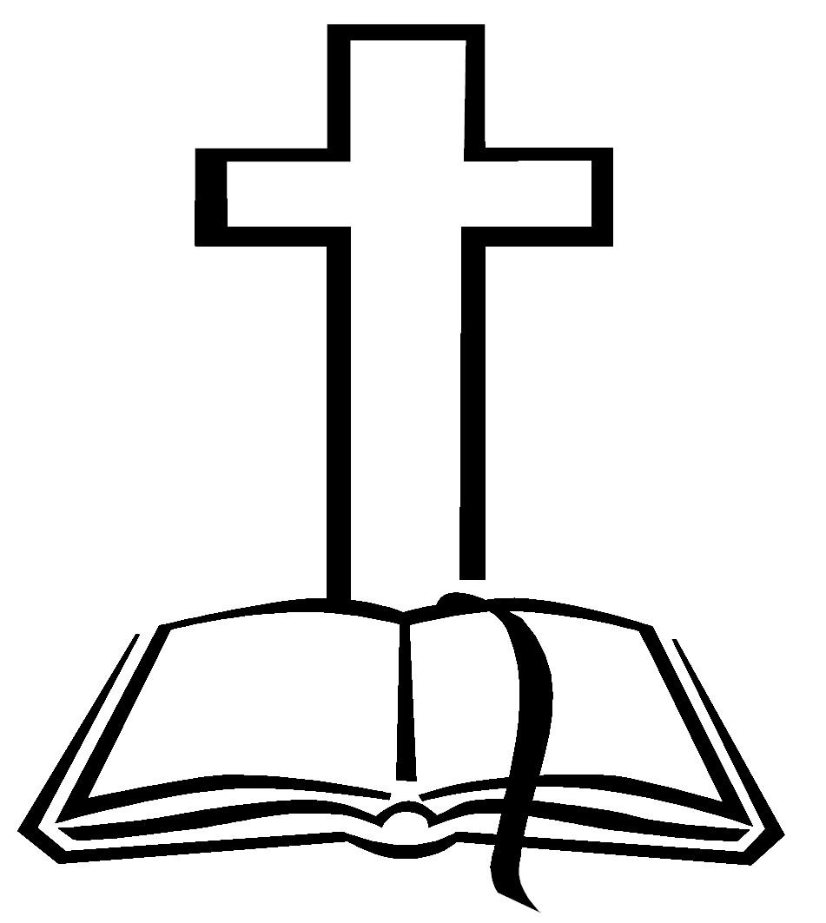
So now let’s go to page 41 in our study book to dig into this passage.

Let us hold fast the profession of our faith without wavering;
(for he is faithful that promised;) – Hebrews 10:23

